USER REPORT
K+G WETTER GmbH
August, 2019

The strong combination of man and technology
for pure enjoyment
Obere Metzgerei Franz Winterhalter relies on bowl cutters and mixer angle grinders from K+G Wetter
The products of the Obere Metzgerei Franz Winterhalter, which are acclaimed in the truest sense of the word, come from the beautiful Black Forest. Raw, boiled and cooked sausages as well as smoked and cooked ham have been made here with a love of workmanship since 1749. The innumerable awards, which impressively prove the enjoyable quality of the specialities from Elzach, have already become a tradition. Be it within the framework of Süffa, IFFA or quality competitions, over the past decades the Obere Metzgerei Franz Winterhalter has received numerous awards as one of the best butcher's shops in Germany and its outstanding products have been honoured hundreds of times with gold, silver and bronze medals.
An experienced team of 150 employees, six regional sales outlets, nationwide popularity, high-quality technology and the passionate commitment of the two brothers and Managing Directors Peter and Wendelin Winterhalter are behind the success. "Our butcher's shop is 270 years old this year, and we are leading it in the 9th generation. That speaks volumes," stresses Wendelin Winterhalter. "He who ceases to be better ceases to be good. My father coined this phrase. And that is exactly how it is. Tradition also means change. You have to preserve what is good, try something new and combine it with your own experience and the skills of your trade."

The bowl cutter as the heart of the butcher's shop
The specialities from Baden are known far beyond the borders of the Black Forest. Throughout Germany, butchers offer products from Baden. From the Elzach Hüttenwurst and Bratwurst to the Schwarzwald Luft Salami, the magic touch is required for the production – finely tuned in combination with the powerful use of machines. "The bowl cutter is the heart of the butcher's shop. Together with the artisan intuition, that is what sets our products apart. Of course, the raw materials also play an important role. But experienced employees and the bowl cutters are especially important. That is why we have been relying on K+G Wetter machines for decades. We are currently using a Cutmix 200 litre bowl cutter and a 130 mm mixer angle grinder," explains Wendelin Winterhalter. “The reason for this has something to do with tradition, if you will. We have the principle of a certain amount of loyalty to our partners. That may be because we Black Forest people are a little conservative. But it has proven worthwhile. If we are convinced of a product, with the people behind it and with the service, then we are all set. This also applies in the case of K+G Wetter. It simply fits, from a human and technical perspective."

Due to the variety of products in the butcher trade, the Obere Metzgerei also needs a bowl cutter that can produce large and small batches in perfect quality. The Cutmix cutting chamber as well as the knife and bowl shape are designed for this purpose. For the production of raw sausage, boiled sausage and cooked sausage, also for the convenience sector, the Cutmix 200 L with its removable baffle plate brings the advantage of a variable cutting chamber into production. This enables the bowl cutter technician to adjust the bowl cutter optimally to the material to be worked with.
The stable base is formed by the cast iron stand which is completely covered with stainless steel on all sides. "Here, of course, the smooth motion is what counts for us, also in terms of occupational safety," says Wendelin Winterhalter. Thanks to the solid machine stand, the special knife shapes can be adjusted precisely and at a minimum distance from the bowl. This ensures a uniform size, especially when working with fine sausage meat.
In addition, there is the power and drive control for controlling the knife and bowl for production with variably adjustable speeds; the bowl speed range is almost twice as high as that of conventional bowl cutters. The experienced cutter master Franz Burger also raves about "his" Cutmix: "This is a very reliable machine. Cleaning is quick and easy and the knives can be easily changed with the torque tool." Thanks to the raised bowl edge, the machine is protected from unnecessary contamination even with thin sausages. A large opening in the bowl ensures even more cleanliness and quick emptying of the cleaning water. It automatically moves to the cleaning position. So the bowl runs empty automatically after cleaning. In addition, almost all surfaces of the bowl cutter are bevelled for hygienically reliable water drainage.

Easy operation and digital preservation of knowledge
The intuitive operation of the bowl cutter takes place using the clearly arranged touch panel. It is also easy to clean. To avoid faulty production, automatic switch-off functions are available for the number of bowl rounds, the meat temperature and the cutting time. "The cutter is also equipped with the CutControl software from K+G Wetter. This is where we are now, where it makes sense to implement work processes with the use of digital recipe management. This is particularly suitable for a continuous product. Of course, the skills of our cutter masters are also decisive. One experienced employee is about to retire. We want to preserve some of his know-how. I think that the technology supports us very well here", Wendelin Winterhalter is sure. "Here too we know K+G Wetter will be by our side when it comes to implementation. That's what a good, continuous partnership is all about."

Safe hygiene even when mincing
Also part of the production of the Obere Metzgerei is a Mixer Angle Grinder E 130 from K+G Wetter. Thanks to the simple installation and removal of the mixing shaft, the mincer quickly becomes a mixer angle grinder and thus offers more flexibility. The feeder worm can also be removed easily, which simplifies cleaning and visual inspection. Additional safety in terms of hygiene is provided by flushing channels behind the mixing shaft, feeder worm and meat worm.
For homogeneous mixing and red-white distribution, the feeder worm and meat worm work together. This two-worm principle, with the different pitches of the worms, ensures a constant filling flow in the direction of the cutting set. At the same time, the temperature of the material only increases slightly. "The work with the mixer angle grinder runs just as smoothly as with the bowl cutter. And when something does happen – which is really rare – K+G Wetter's service has always been top-notch over the years and things can get going again quickly," says Johannes Haiger, production employee at Obere Metzgerei Franz Winterhalter.

Experience and technology for future challenges
In the manufacture of high-quality products, the perfect connection between user and machine is essential – as is finesse, Wendelin Winterhalter is confident: "Experience is required, be it when it comes to cutting or in other areas. Let's take salami as an example, for example in the climatised room. Is the humidity right? Is it not right? I go in there every Sunday and then I just smell. I'll know as soon as it's right. Our industry is facing major challenges. High-quality, enjoyable results are all the more important. I can only achieve this if everything works together optimally, from the machines to the people. I know that I can count on K+G Wetter – not only on the technology, but also on my contacts and their service. I can just count on it." With their strong team and the powerful technology of K+G Wetter, Peter and Wendelin Winterhalter and their company are tackling the challenging tasks ahead. They continue to provide real pleasure.

Words: 1,276
Characters including spaces: 7,727

K+G WETTER GmbH
K+G Wetter is a global partner of choice when it comes to manufacturing high-quality, reliable meat-processing machinery. K+G Wetter develops innovative bowl cutters, meat grinders and mixers for butchers and skilled operators engaged in the meat-processing trade. The sophisticated technology and high-quality processing features of K+G Wetter machines play a significant role in bringing about customers’ corporate success. An internationally renowned brand, this company from Biedenkopf-Breidenstein in Hesse (Germany) supports its customers by dispensing personalised and individual advice.
www.kgwetter.de

Press image 1:
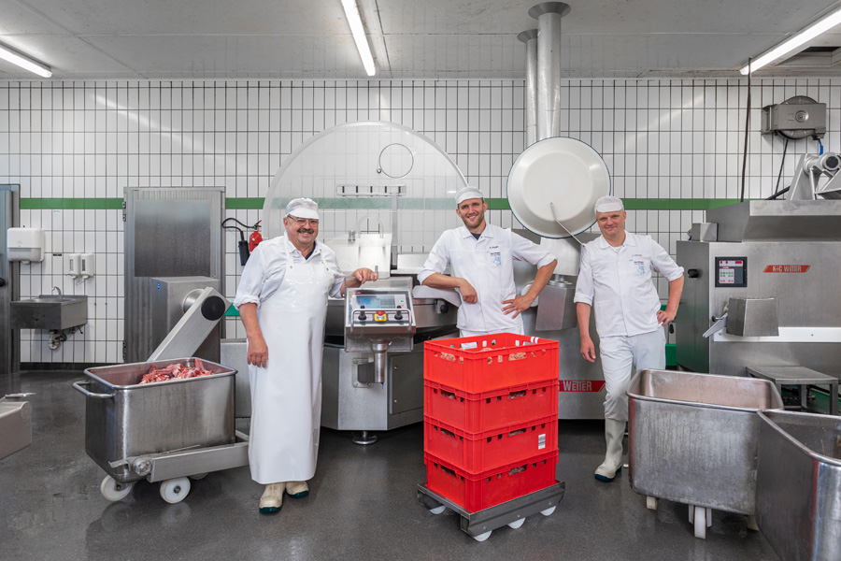
© K+G Wetter

Press image 2:
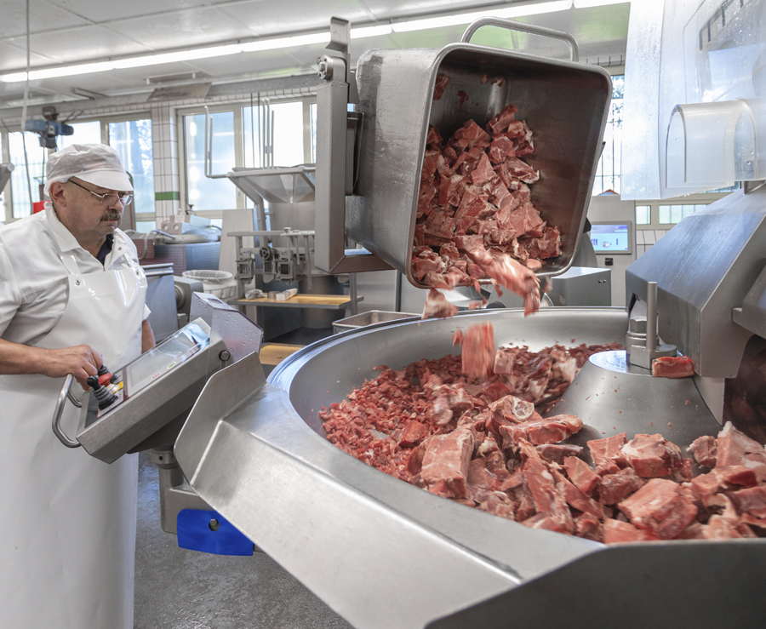
© K+G Wetter

Press image 3:
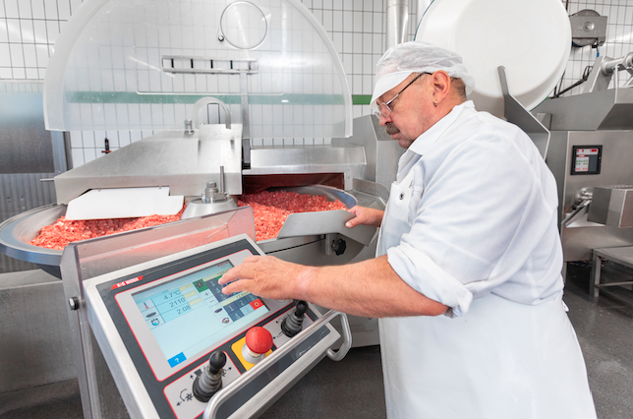
© K+G Wetter
Picture caption: Ensures simple and self-explanatory cutting: the optimized surface of the touch panel from K+G Wetter.

Press image 4:
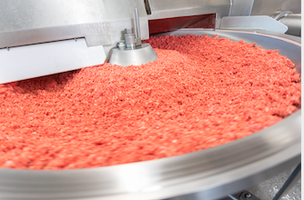
© K+G Wetter

Press image 5:
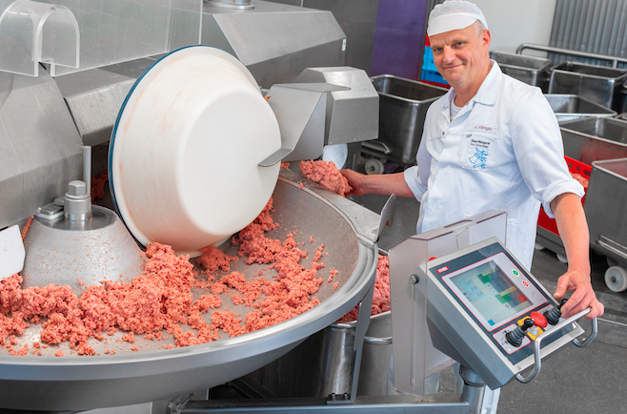
© K+G Wetter

Press image 6:
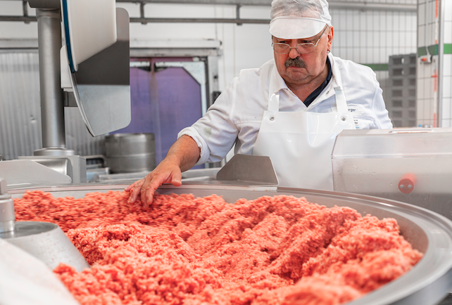
© K+G Wetter
Picture caption: The connection for enjoyable products: Finesse and outstanding technology.

Press image 7:
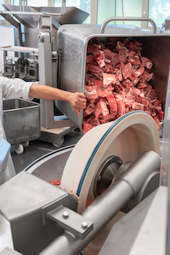
© K+G Wetter

Press image 8:
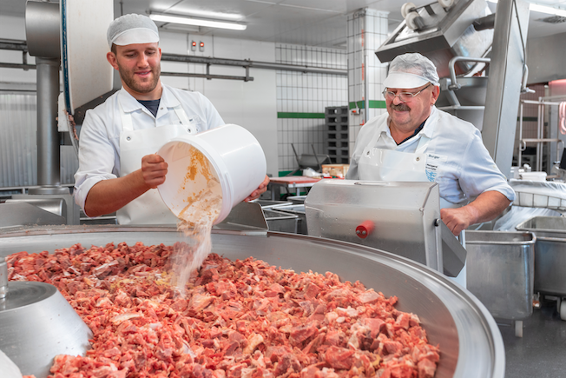
© K+G Wetter

Press image 9:
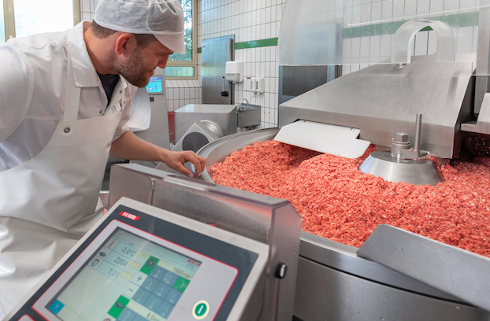
© K+G Wetter

Press image 10:
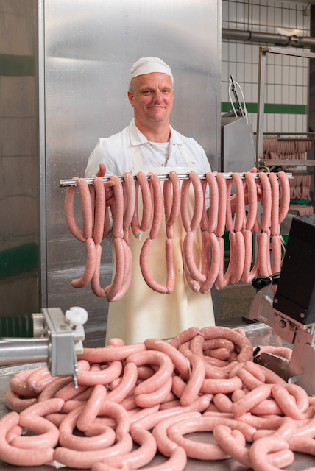
© K+G Wetter

Press image 11:
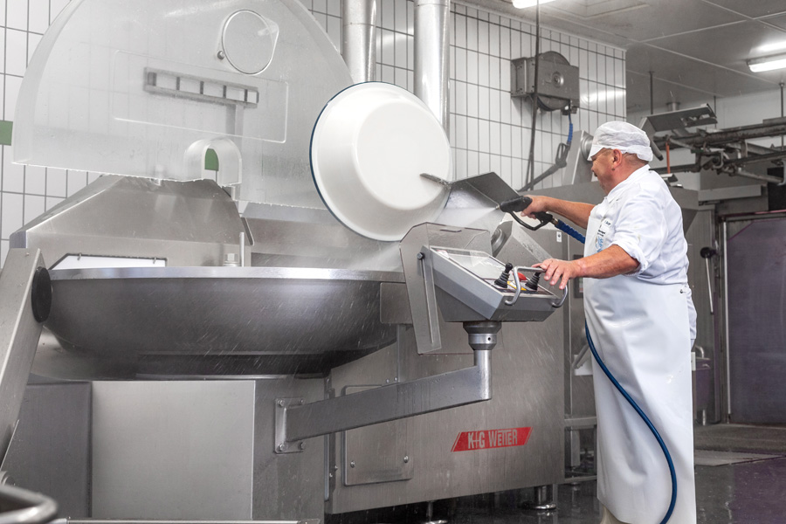
© K+G Wetter

Press image 12:
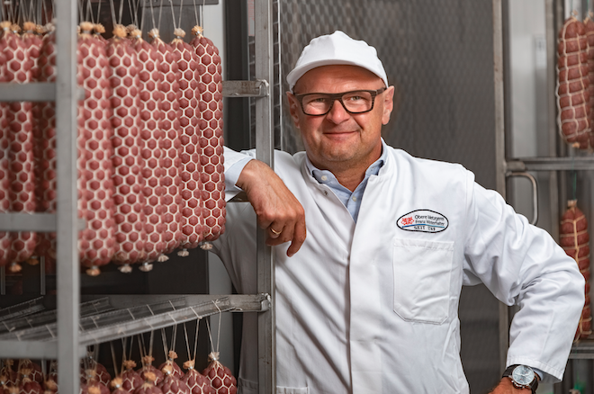
© K+G Wetter
Picture caption: Wendelin Winterhalter, Managing Director of Obere Metzgerei Franz Winterhalter

Press image 13:
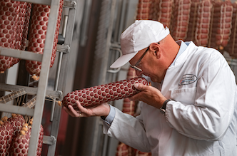
© K+G Wetter
Picture caption: Wendelin Winterhalter, Managing Director of Obere Metzgerei Franz Winterhalter
Press image 14:
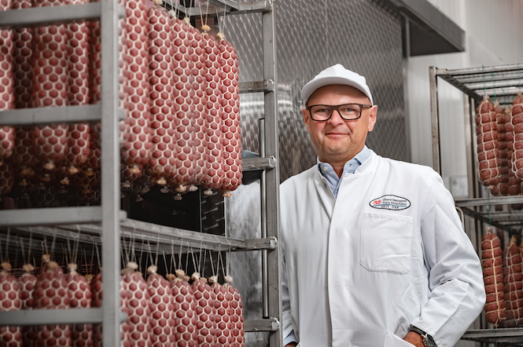
© K+G Wetter
Picture caption: Wendelin Winterhalter, Managing Director of Obere Metzgerei Franz Winterhalter

Contact details:
K+G WETTER GmbH
Goldbergstrasse 21
35216 Biedenkopf-Breidenstein
www.kgwetter.de

Your personal contact:
Stefan Köhler
PR/Media
s.koehler@psv-marketing.de

