PRESS RELEASE
K+G WETTER GmbH
June 12, 2019

A strong software duo for efficient meat processing
Solutions from K+G Wetter also impress in the butcher trade with their friction-free processes and maximum quality
Craft and computers – can they work together? Absolutely, as K+G Wetter can successfully prove with the software duo CutControl and CutVision. While the experts for robust meat processing machines were already carrying out truly pioneering work years ago, PC-supported processes have now become indispensable in the modern butcher's trade. Efficient processes, reproducible quality, or the reliable documentation of all production steps – these are all added values which, in addition to the industry, craft butchers can no longer and no longer want to do without. K+G Wetter therefore optionally equips its bowl cutters and vacuum bowl cutters with effective software that combines high functionality with ease of operation.

CutControl: Once tasty, always tasty
As an automatic program control with digital recipe management, CutControl guides you step by step through the entire production process. Knife shaft speed, bowl speed, temperature, number of cycles: All these values can be easily defined in advance, adapted to the respective recipe. The information is supplemented by corresponding work instructions, e.g. loading of the bowl cutter, the addition of ice, or of spice, etc. Once created, the programs and recipes are reproducible at any time and can be called up again and again for precise product manufacture.
The individual production steps are clearly indicated on a display on the bowl cutter and ensure error-free work. Depending on the switch-off value set, the bowl cutter then stops after each working step and the bowl cutter master is informed about the next necessary working step. This avoids errors and allows employees to not have to keep an eye on the process during the bowl cutter process. The automatic quantity conversion also saves a lot of time: If the batch size of a recipe changes, CutControl adjusts the required quantities within seconds.

CutVision: Complete documentation
The CutVision software reliably and seamlessly documents all quality-relevant data that is generated during the production of sausage products or other products – and this fully automatically with the start of the bowl cutter. Whether sausage meat temperature, knife and bowl speed, or motor rating: These and other measured values are recorded immediately. The data can be read out and stored in a wide variety of forms and formats as required. All data can be reliably assigned to the respective batch. This makes CutVision the ideal solution for fulfilling increasing quality demands, responsibility towards customers and, last but not least, legislation.

Intuitive touch panel
What both pieces of software have in common is that they do not require extensive training and thus have a direct positive effect on the process flow. The touch panel is also characterised by easy operability. It is integrated as standard into all K+G Wetter bowl cutters. With the clear and easy to grasp structure of the operation via the touch panel, familiarisation is easily implemented and practically self-explanatory. With manual dexterity and supported by state-of-the-art technology, enjoyment is created that convinces again and again.

Words: 508
Characters including spaces: 3,302

K+G WETTER GmbH
K+G Wetter is a global partner of choice when it comes to manufacturing high-quality, reliable meat-processing machinery. K+G Wetter develops innovative bowl cutters, meat grinders and mixers for butchers and skilled operators engaged in the meat-processing trade. The sophisticated technology and high-quality processing features of K+G Wetter machines play a significant role in bringing about customers’ corporate success. An internationally renowned brand, this company from Biedenkopf-Breidenstein in Hesse (Germany) supports its customers by dispensing personalised and individual advice.
www.kgwetter.de

Press photo 1
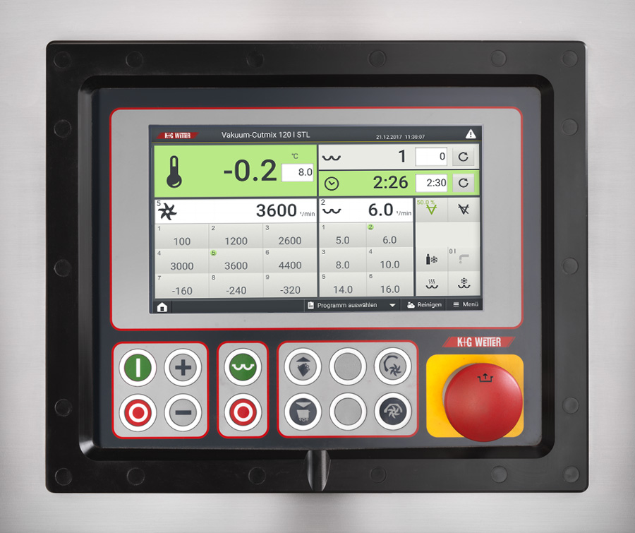
© K+G Wetter
Caption: : Smart duo: CutVision and CutControl share the fact that they do not require a long training period and thus immediately provide for better processes.

Contact details:
K+G WETTER GmbH
Goldbergstrasse 21
35216 Biedenkopf-Breidenstein
www.kgwetter.de

Your personal contact:
Stefan Köhler
PR/Media
s.koehler@psv-marketing.de

