Case Study
K+G Wetter
September 2020

How “old“ and “new world“ can deliciously blend
Zicks Specialty Meats Inc. boosts product quality and taste with a new K+G Wetter mixer angle grinder

“Zicks Specialty Meats Inc.” is located in Berrien Springs (Michigan). It has been in meat specialties since 1961. The company’s history began with the opening of “Zick’s Grocery store“ in St. Joseph (Michigan). Since then it has been transformed into a meat processing plant “Old World Style“.

Over the years, the Zick family and their team have become famous for their smoked sausages, jerky, and unique, delicious snack sticks. The tradition of meat processing came from a German immigrant. “He came to the USA in 1952 and worked for my father. I had the privilege to work under and learn from him”, remembers Garry Zick, CEO of Zick’s Specialty Meats.

Tradition means a lot to the Zicks: Many of the products produced in Berrien Springs are, due to their ingredients or their recipes, so unique and traditional that they can´t be found anywhere else in the USA. Alligator, Elk or Kangaroo – the range of different types of meat specialties is exclusive and unlimited. Also, a lot of retail specialty products and additional services are provided. A part of their products can be found and ordered in their online shop, where different types of products and individually composed packages are available, e.g. a „Cheese and Meat-Box“ for the next barbecue.

“We are dedicated to find new and exciting ways to thrill our customers’ taste buds, while preserving the old European recipes that have been kept secret for generations. We produce over 20 flavors of snack sticks and beef jerky and over 30 different kinds of bacon, sausages, and other smoked meats“, emphasizes Garry Zick.

The Zick family takes great pleasure in the production of their goods. This passion can be found in the excellent taste of their products. The family and their employees are devoted and enthusiastic about finding the best quality meats, spices and equipment to make products of best and unique quality.

“Our main production at this time is shelf stable snack sticks and extruded jerky products. Our secondary product lines are dry and fermented salami, pepperoni, chorizo, kolbasz, and many European style products as well as bacon and hams”, describes Zick.

The product range also includes lunch meat type products such as bologna, summer sausage, mettwurst, bratwurst, Polish and Italian sausages. Zick: “Everything we produce is smoked and cooked or dried.”

“When I saw the mixer angle grinder, I knew this is the time for us to buy”

The Zick family began and will remain family owned and operated, so they were looking for a new angle grinder as an investment for the company’s future. When Garry Zick first saw the mixer angle grinder 130 from K+G Wetter at IFFA trade fair three years ago, he was immediately impressed about its high quality and application-oriented design. “After learning Tom Springman represents the line I knew this is the time for us to buy”, he remembers.

“As we are a trusting customer of Kerres USA and as they have proven over the years to provide expertise and commitment to the products they sell and service they provide, it was an easy decision. We sort of knew the outcome of the quality we would get but it was the design that helped us make up our minds. We decided for a mixer angle grinder which is the best solution for our daily business.
The cleverly thought-out details of K+G Wetter’s mixer angle grinder make the difference for Garry Zick: The mixer angle grinder is actually the only one that offers direct access to the hopper and therefore allows easy and secure cleaning.
The simple installation and removal of the feeder auger and the mixing shaft saves time for the Zick family, guarantees hygienic safe cleaning results and makes the work much easier. The sorting device for discharge of hard parts of the meat during the grinding process is also a clever solution, that guarantees perfect end products. The handling is extremely easy and this makes it very easy for the machine operator to use the unit.
The clever ejecting device for the meat auger and the cutting set are additional intelligent features which make daily work more comfortable.

All steps of processes and the product quality have been improved

The machine immediately improved the quality of the products across the line and also the speed at which the employees were able to keep up with mixing and grinding. “Also, it is much easier and safer to clean and maintain“, says Zick. “The mixer angle grinder gives us more latitude in our formulations because our outcome on the precision of the grind is always consistent.“

“The entire material flow in the meat auger and through the cutting set is super even, so that we get an outstanding cutting pattern without smearing and hardly any temperature increase worth mentioning, I never knew it like this before“, Garry is enthusiastic.

Also, it strongly grinds pre-shred frozen meat of different types down to -8° C without problems which allows the Zicks to perfectly work with different types of meats and their individual structure. The angle grinder is - as all K+G Wetter constructions - engineered to adapt to and improve existing workflows which leads to even faster processes.
Garry Zick: “There is no smearing or back pressure or flow. The mixing of spices and ingredients is something we have not had much luck in the past with other systems. The mixer angle grinder E 130 from K+G Wetter ensures with the cleverly thought out mixer shaft principle in combination with the feeder worm highly intensive and thorough mixing processes. It has improved each step of our process after the grinding step - protein extraction, particle definition, shelf life, texture and even the product color. We were amazed at the finished product and on the different items we tried it with. The grinding process delivers perfect results, even if we use different cutting sets for different applications.”

“After 50 years of working in this industry I am sure we have the best grinder in the world. The next generation of Zicks will have the best machinery to work with. It has improved our whole product line instantly. I am training my grandson who is now 16 years old in the sausage kitchen. He will never know a lower level of quality and always know what a good grinder can do for you.“

Photo:

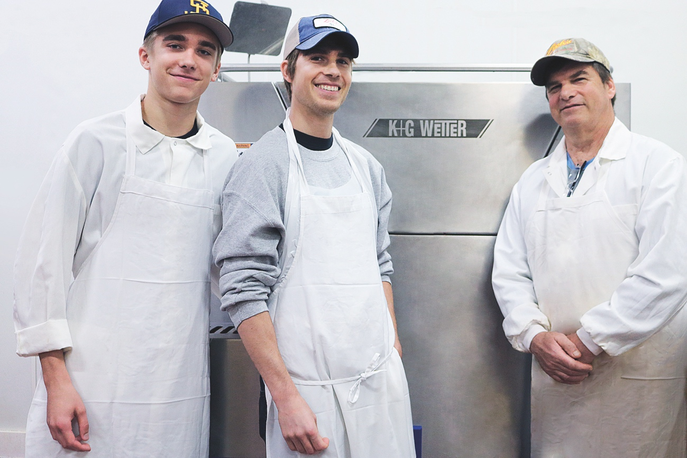

© Zicks Specialty Meats Inc.

Caption: Tradition is more than important to the Zicks: As the company has always been family-owned and will remain so in the future, they were looking for a new mixer angle grinder as a long-term investment in the future. The decision was made in favor of a mixer angle grinder 130 from K+G Wetter.

Contact information:
K+G Wetter GmbH
Goldbergstrasse 21
35216 Biedenkopf-Breidenstein
www.kgwetter.de

Contact person:
Katharina Hennig
PR/Media
T. +49 (0) 2 71 . 77 00 16 – 160
F. +49 (0) 2 71 . 77 00 16 - 29
k.hennig@psv-neo.de
www.psv-marketing.de

