PRESS INFORMATION
K+G Wetter GmbH
July 2020

Clever concept for improved hygiene in the process
Solutions in numerous details ensure hygiene safety

Increasing demands on production processes and compliance with the highest hygiene standards: The meat industry is experiencing a similar development with ever more rapid progress in all areas. This also brings with it new challenges for technical solutions in bowl cutter construction. As a result, the experts at K+G Wetter are constantly developing new approaches in order to stay more than one step ahead and set new standards with their clever solutions.

The development of the new industrial bowl cutter series "Hygienic Secure" has broken completely new ground. So, every detail with regard to the technology but also with regard to the process technology was closely examined. The focus here was on the economy and optimization of process sequences, hygiene and safety, ease of operation as well as ergonomics and energy efficiency. "Hygienic Secure" excels in all areas. Together, these factors ensure that the end products are of the highest quality.

Easy and hygienically safe cleaning thanks to innovative design

Seals are wearing parts which need to be replaced at certain maintenance intervals over the course of a machine's life. In the new "Hygienic Secure" machine generation from K+G Wetter, the very vulnerable hygienic area between cutter bowl and vacuum vessel now operates completely without seals.

"The issue of wear and tear and the risk of contamination has been settled at this point," says Volker Schlosser, International Sales Manager at K+G Wetter. "Especially the advantages regarding a hygienically safe cleaning process have reached a completely new dimension. Where there is no seal, there will be no possibility of deposits forming." This is precisely why the product range is also called "Hygienic Secure", as it stands for the best hygiene and (product) safety properties.

The two-part stainless steel lid (knife and noise reduction lid) is also a feature of "Hygienic Secure". The loading and unloading time is significantly reduced. An additional special feature and novelty: The cover strip on the knife lid is self-adjusting and can be removed without tools for cleaning. Both the lid strip and the mushroom topper and bowl scraper, which can be removed without tools, can be easily and thoroughly cleaned - for smooth production processes, maximum hygiene and product safety.

Even the cleaning of the vacuum vessel area, which is usually difficult to clean, is hygienically safe with the new design. Two large cleaning flaps in the vacuum vessel, which can also be moved without tools, ensure that the area is completely visible and accessible and can therefore be cleaned safely. The "Hygienic Secure" series lives up to its name and, like all machines from K+G Wetter, provides extra safety, hygiene and efficiency in the entire production process.

Volker Schlosser: "With this new generation of machines we are now offering our customers cutters whose development technology has taken a true quantum leap. Just some of the key words here are hygiene, safety, energy efficiency and ease of operation, even when servicing is required.
Anyone investing in a new bowl cutter today will be looking specifically for solutions which provide comprehensible advantages and benefits and eliminate hygiene risks. We have taken all this into account in the development of the new generation of machines, also with the feedback we have collected from customers and their experiences. It is a pleasure for me personally to present and sell this generation of bowl cutters on the market together with our dealers. After all, our brand stands for quality and top-quality machines".

K+G Wetter
K+G Wetter is a globally sought-after partner for the production of high-quality and reliable machines for meat processing. K+G Wetter develops advanced bowl cutters, grinders and mixers for butchers and skilled workers in trade and industry. Thanks to their sophisticated technology and high-quality workmanship, K+G Wetter machines contribute significantly to the corporate success of its customers. As a world-famous brand, the company from Biedenkopf-Breidenstein in Hesse provides its customers with personal and individual advice.
www.kgwetter.de

Press photo 1:

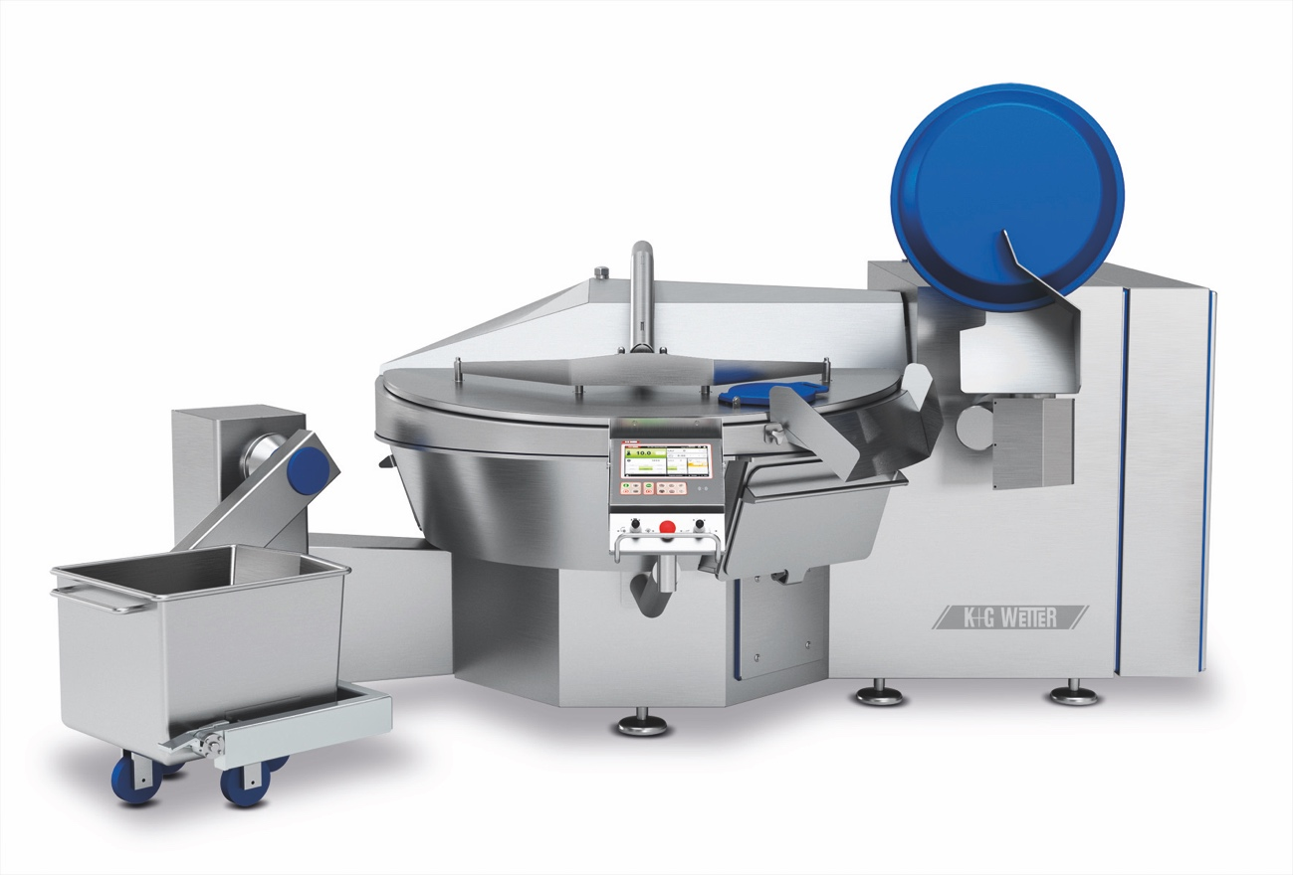
© K+G Wetter

Caption: Details make the difference: The vacuum industrial bowl cutters of the "Hygienic Secure" series rely not only on the tried and tested K+G Wetter quality but also on innovative approaches. For new standards in efficiency, safety and hygiene.

Press photo 2:

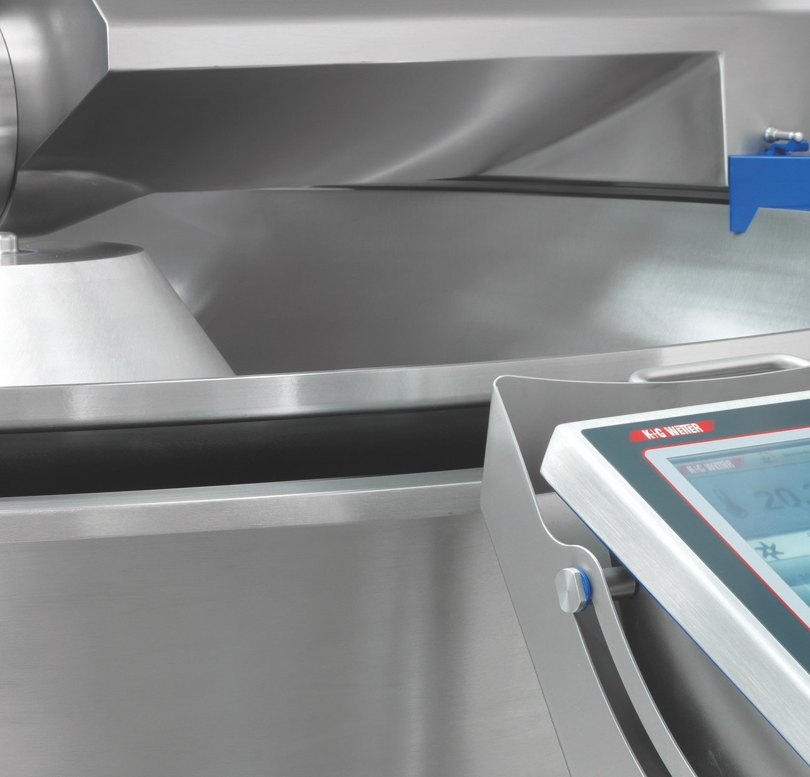

© K+G Wetter

Caption: Easy and safe cleaning: No seal is required between the cutter bowl and the vacuum vessel. This ensures hygienic cleanliness.

Press photo 3:

Caption: "Our brand stands for quality and top-quality machines," emphasises Volker Schlosser, Sales Manager International at K+G Wetter.

Contact information:
K+G Wetter GmbH
Goldbergstrasse 21
35216 Biedenkopf-Breidenstein, Germany
www.kgwetter.de

Your contact:

Katharina Hennig
PR/Media
Phone +49 (0) 2 71 . 77 00 16 - 160
Fax +49 (0) 2 71 . 77 00 16 - 29
k.hennig@psv-neo.de
www.psv-marketing.de

