PRESS RELEASE
K+G Wetter GmbH
April 2021
Vacuum Bowl Cutter VCM 200

Strong all-rounder from K+G Wetter ensures a new level of hygienic security
Newly developed VCM 200 vacuum bowl cutter rounds off the “Hygienic Secure” range and is distinguished by the highest levels of hygiene and its compact design.

K+G Wetter consistently focuses on the needs of its customers with its machines and clever solutions for industry and the butcher trade. This has already been successfully demonstrated by the company time and again. Most recently, the machine manufacturer from the Hesse region of Germany caused a sensation with its “Hygienic Secure” series of industrial bowl cutters. Now the traditional company is launching another innovation: With the powerful VCM 200, K+G Wetter is rounding off its “Hygienic Secure” range, thereby combining the proven benefits of its machines with clever characteristics.
Thanks to their varied developments, the K+G “Hygienic Secure” industrial bowl cutters deliver a sustainable advantage in terms of efficiency. The latest AC drive system, which is fitted as standard, guarantees a high level of energy efficiency and is practically maintenance-free.

Proven features meet innovations
“During development of the new VCM 200 vacuum bowl cutter we were able to draw on experience gained from the new vacuum bowl cutters in the ‘Hygienic Secure’ range. Of course, the practical experience already gained was advantageous here. We were already able to gain such experience with the VCM 120, 360 and 550 litre versions and the VCM 200 vacuum bowl cutter has now been added to the ‘Hygienic Secure’ range as a connecting link, so to speak, between the cutter size for the butcher trade and the large 360 and 550 litre industrial bowl cutters. We are confident that this will once again raise the successful previous generation of the 200 litre version to a new level. For our customers, this now rounds off the latest-generation range of vacuum bowl cutters of all sizes,” comments design manager Andre Weyand.
Patented knife cover strip can be clipped in and out without tools
The newly developed vacuum bowl cutter offers numerous technical design highlights that make all the difference in terms of hygienic security and efficiency. A key characteristic is the split vacuum lid. This enables significantly faster loading and unloading of the cutter bowl, because only the front section of the lid needs to be opened for this purpose. The knife cover with removable baffle plate ensures optimum adaptation of the cutting chamber to the respective product. This is already installed as standard in the knife cover.

The absence of seals is another benefit in terms of hygiene: This is because the area between the cutter bowl and the vacuum vessel in the K+G Wetter solution requires no seal at all. Replacement, wear and contamination risks are relegated to the past. Contamination cannot occur if there are no inaccessible areas. This means that costs are no longer incurred for replacing seals.

The patented, removable knife cover strip is self-adjusting. For cleaning purposes it can be easily clipped in and out without using tools. Cleaning is effortless and there are no concealed corners where deposits could form. Since it is easy to visually check the success of cleaning, contamination caused by product residues is eliminated. With its vertical movement and compensatory capability the knife cover strip is able to reduce the frictional resistance that occurs. This effectively counteracts potential material abrasion and wear. The bowl support pad and bowl scraper can also be removed without using tools and are also self-adjusting. This saves time, facilitates safe and easy cleaning and guarantees the highest standard of hygiene.

The two large cleaning flaps in the vacuum vessel, which can be opened without using tools, also deliver significant added value in terms of hygienic security for the new VCM 200 and the other “Hygienic Secure” industrial bowl cutters. They allow easy access through the generously sized openings into the vacuum vessel area. This can therefore be easily and quickly cleaned in a hygienically secure manner. A high level of product safety is ensured as a result.

A further special feature is the greater ground clearance with the same bowl or working height than the previous generation. This also greatly facilitates the cleaning process. Operation of the machine is simple and self-explanatory via an intuitive touch panel. The panel layout can be customized according to the customer’s requirements.
All of the relevant machine parts are fully monitored and the corresponding parameters can be viewed via the touch panel. For servicing, all data can be retrieved quickly and easily. All of the relevant production parameters can be entered and saved via the panel. These include knife and bowl speeds, shutdown functions, etc. Using the CutControl recipe management software, the machine operator is guided step-by-step through saved recipes. Errors in production are practically excluded. Consistent and reproducible product quality is ensured. If necessary, all production steps can be traced back – the CutVision quality management software is provided for this purpose.

Compact dimensions have been achieved despite the fully integrated design. The controller is installed within the machine itself. Complex cabling to an external control cabinet is therefore not necessary. This ensures significant benefits in terms of hygiene. Moreover, setting up the machine is simple and fast. The vacuum pump – a maintenance-free water ring pump – is also installed in the machine body.

Furthermore, the newly developed vacuum bowl cutter possesses the proven advantages of K+G Wetter machines, such as an especially solid and robust construction that guarantees smooth running. For added safety, efficiency and quality that you can ultimately taste.

K+G Wetter
K+G Wetter is a global partner of choice when it comes to manufacturing high-quality, reliable meat-processing machinery. K+G Wetter develops advanced cutters, grinders and mixers for butchers and skilled workers in the meat-processing trade and industry. The company's sophisticated technology and high-quality processing mean that machines from K+G Wetter contribute significantly to customers' business success. As a world-famous brand, the company from the Breidenstein district of Biedenkopf, in the German State of Hesse, supports its customers with personal and individual advice.
www.kgwetter.de

Press image 1:
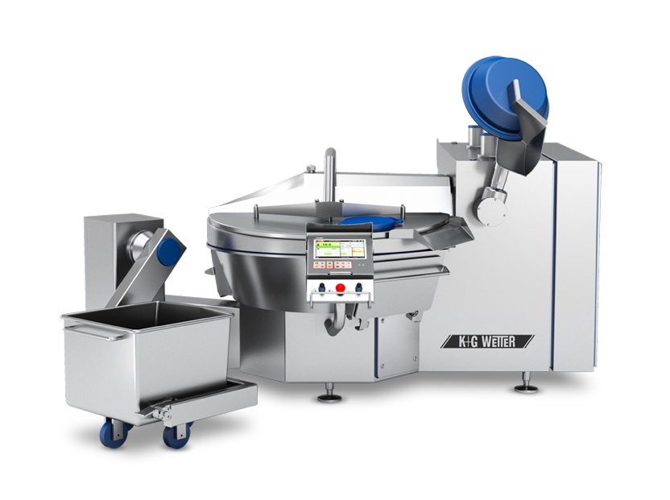
© K+G Wetter

Photo caption: The newly developed VCM 200 vacuum bowl cutter from K+G Wetter offers numerous technical design highlights. These ensure added benefits in terms of hygienic security and efficiency.

Press image 2:
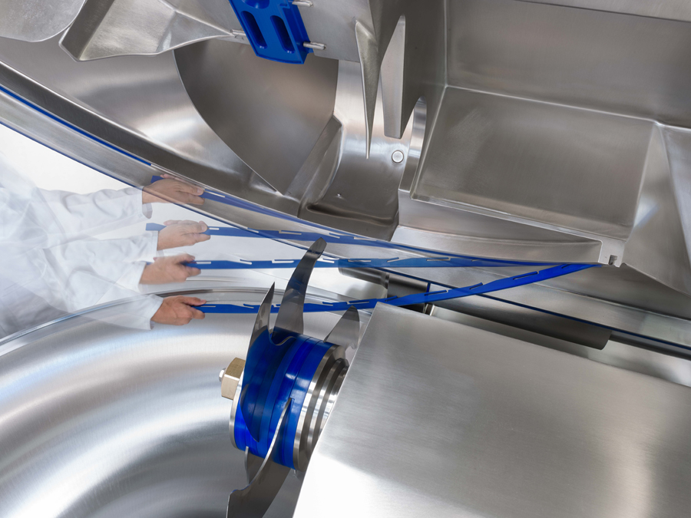
© K+G Wetter
Photo caption: The patented cover strip on the knife cover is self-adjusting. For cleaning, the strip can be easily clipped in and out without using tools.
Press image 3:

© K+G Wetter
Photo caption: “We are confident that we will once again raise the successful previous generation of the 200 litre version to a new level with the VCM 200”, emphasises K+G Wetter design manager Andre Weyand.

Contact details:
K+G Wetter GmbH
Goldbergstrasse 21
35216 Biedenkopf-Breidenstein
www.kgwetter.de

Your contact partner:

Katharina Hennig
PR/Media
T. +49 (0) 2 71 . 77 00 16 - 160
F. +49 (0) 2 71 . 77 00 16 - 29
k.hennig@psv-neo.de
www.psv-marketing.de

