K+G Wetter Press Release

August 2022

Veggie needs vacuum
Plant-based protein products benefit from K+G Wetter vacuum bowl cutters
Finding plant-based alternatives to popular meat products on supermarket shelves is now easy: the fact that vegan meat sausage, vegetarian burger patties or grilled steak made from plant protein are on offer is taken for granted these days. Such products are often purchased by shoppers who simply want to eat less meat or are looking for variety. In 2021, according to the German Federal Ministry of Food and Agriculture, 10% of the German population ate a vegetarian diet and 2% a vegan diet – in each case twice as many as in the previous year! This represents over 10 million people who choose a diet that is free of meat and fish or entirely free of animal products. (Source: https://proveg.com/de)
Vacuum technology is indispensable when using bowl cutters to produce vegetarian and vegan products. There are various reasons for this: First, it is necessary to chop vegetable proteins in the so-called cold range, i.e. below 40⁰C, to prevent denaturation, i.e. the irreversible destruction of protein structures by excessively high temperatures. The use of a vacuum bowl cutter is already beneficial here, since a cooling effect occurs in the area of the so-called strong vacuum above 80%. Vacuum bowl cutters from K+G Wetter can be operated consistently at 95% without any level losses. The vacuum is generated by a particularly economical water ring pump. This prevents oil contamination and the pump is maintenance-free.
To produce sausage meat, fibres and proteins, whether animal or vegetable, must be broken down to such an extent that an emulsion is initially formed. In an 80% vacuum or more, the fibres swell, which in turn makes a finer bond possible during mincing. The use of vacuum technology also allows longer protein chains to form: as a result of the swelling process, fine cutting is achieved so that water and oils can then bind with them.

Vacuum also plays a decisive role in the process, because it allows otherwise necessary – and sometimes controversial – additives to be completely or partially dispensed with. As with animal products, the flavour of the emulsion produced is intensified when chopped under vacuum, meaning that the salt content, for example, can be reduced.
Moreover, the strong vacuum generated by the K+G Wetter bowl cutters lowers the oxygen content in the emulsion, thereby reducing oxidation. This considerably increases the products’ shelf life.
Of course, just as for processing animal proteins, selecting the right knives for producing the emulsion plays a key role. Fine sausage or raw sausage knives can be used here. Directly associated with this is the fact that adapting the cutting chamber in the knife cover to suit the corresponding product offers benefits. The solution K+G Wetter offers for this is a removable baffle plate, which guarantees an optimal spatial geometry for the cutting process. A further key technical parameter here is absolute precise matching of the knife and bowl speeds to the product being processed.
In order to run these processes consistently and reproducibly, the use of recipe management software makes good sense. With its CutControl software, K+G Wetter offers exactly this tool. The operator is guided step by step through the production stages. All parameters from knife and bowl speeds and shut-down functions through to bowl revolutions, times and temperatures are monitored to control the process. A particularly important aspect here is the precise monitoring of temperatures in order to maintain the cold range below 40⁰C.
Another important aspect, again independent of animal or vegetable products, is hygiene. K+G Wetter has set a milestone with its Hygienic Secure range of bowl cutters. All parts of the machine are designed to allow safe and secure cleaning. Examples include the removable knife cover strips, the removable bowl support pad and the open gap between the bowl and vacuum vessel. An additional special feature is that the entire vacuum system pipework is safe and easy to clean. In other words, all of the areas in which one may suspect deposits to accumulate.

Press photos: © K+G Wetter
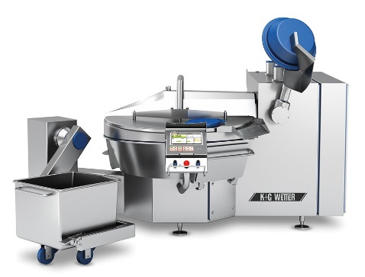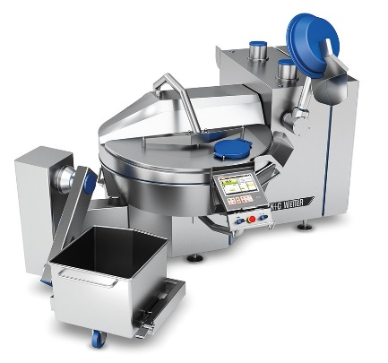

Photo caption: A bowl cutter incorporating vacuum technology is essential for processing vegetable proteins for making vegetarian and vegan products. The VCM series from K+G Wetter, pictured here in the VCM 200 Hygienic Secure, enables fast and energy-efficient strong vacuum generation. This ensures longer protein chains and a finer bond in the production of plant-based sausage meat.

