Press information K+G Wetter

Easier, safer and faster cutting: Customized software solution optimises food production
CutControl and CutVision from K+G Wetter save time and ensure quality

Sausage specialities produced just by touching a button? Ingredients in – product out? Of course, automating food production is not quite so simple, because where bowl cutters and grinders are used in butcheries, expert machine operators are there to ensure quality and taste. However, customized control software makes many of the work stages in the butchers’ trade and at industrial butcheries easier, safer and faster.

CutControl and CutVision from K+G Wetter optimise the bowl cutters in the Cutmix series by adding recipe management, production and quality management software solutions. Moreover, a barcode scanner ensures that the right ingredients are always at hand.

The benefits of the CutControl recipe management software have already convinced many K+G Wetter customers: “It is no longer necessary to enter each step individually. Instead, a recipe is created just once which contains all work steps, together with the precise ingredients and quantities,” explains Patrick Stephan, production manager at Steinemann Holding GmbH & Co. KG, a long-standing K+G Wetter customer. While the software doesn’t replace humans, it means that staff no longer need to monitor, adjust and trigger every step. It also allows them to perform other tasks in parallel or prepare the next ingredient or batch in the busy production environment. This offers a correspondingly large time saving. Moreover, according to Patrick Stephan, “This makes it even easier to produce consistent and repeatable high quality.” Steinemann has also retrofitted and optimized the older vacuum cooking cutter from 2011 with the CutControl software. Why? It lowers the risk of producing reject batches, maintains the same degree of quality thanks to the automatic quantity conversion function, and the automated programme steps save time. This ultimately translates into greater yield. A comparable software solution with stored mixing programmes that automatically delivers optimal results with different products is also available, for example, with the MW 200 mixer grinder from K+G Wetter.

Equipping the bowl cutter with a barcode scanner in addition to CutControl offers a further level of production safety. Each ingredient in a recipe is assigned a barcode during work preparation, and this is first scanned during the corresponding programme step. Only if the code is correct the employee is then able to add the meat or spice and continue processing. Reject batches caused by adding incorrect ingredients or quantities are therefore almost completely prevented.

The CutVision software automatically records the knife and bowl speeds, consumption (such as the automatic addition of water), the degree of vacuum applied and other parameters in K+G Wetter bowl cutters. Energy consumption can also be recorded as an optional extra, which provides additional important information for pricing calculations. The software generally makes all information about produced batches available, along with time data. This ensures that butchers are able to check and verify how their products are being manufactured at any time – a key pillar for ensuring food safety, in line with an HACCP concept, for example. Many K+G Wetter customers also rely on CutVision for evaluating test batches and developing new recipes. This supports the potential for making savings and optimisations.

Press photo (credit: K+G Wetter)
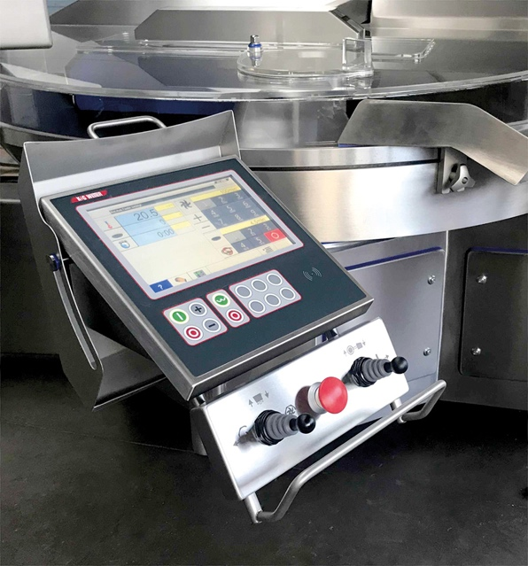
With CutControl, K+G Wetter cutters are provided with a recipe management software that makes food processing easier, safer and faster.

